
Rossmoyne Senior High School
Semester Two 2011

Trial WACE Examination, 2011

Question/Answer Booklet

MATHEMATICS 2A/2B

Section One:

Calculator-free

NAME:
TEACHER: Mr. Fletcher Mr Tanday

Time allowed for this section
Reading time before commencing work: five minutes
Working time for this section: fifty minutes

Materials required/recommended for this section

To be provided by the supervisor
This Question/Answer Booklet
Formula Sheet

To be provided by the candidate
Standard items: pens, pencils, pencil sharpener, eraser, correction fluid/tape, ruler, highlighters

Special items: nil

Important note to candidates

No other items may be used in this section of the examination. It is your responsibility to ensure that you do not have any unauthorised notes or other items of a non-personal nature in the examination room. If you have any unauthorised material with you, hand it to the supervisor before reading any further.

Structure of this paper

Section | Number of questions available | Number of questions to be answered | Working time (minutes) | Marks available | Percentage of exam
Section One:  Calculator-free | 7 | 7 | 50 | 50 | 33
Section Two:  Calculator-assumed | 12 | 12 | 100 | 100 | 67
 |  |  | Total | 150 | 100

Instructions to candidates

- The rules for the conduct of Western Australian external examinations are detailed in the Year 12 Information Handbook 2011. Sitting this examination implies that you agree to abide by these rules.

- Write your answers in the spaces provided in this Question/Answer Booklet. Spare pages are included at the end of this booklet. They can be used for planning your responses and/or as additional space if required to continue an answer.
- Planning: If you use the spare pages for planning, indicate this clearly at the top of the page.
- Continuing an answer: If you need to use the space to continue an answer, indicate in the original answer space where the answer is continued, i.e. give the page number. Fill in the number of the question(s) that you are continuing to answer at the top of the page.

- Show all your working clearly. Your working should be in sufficient detail to allow your answers to be checked readily and for marks to be awarded for reasoning. Incorrect answers given without supporting reasoning cannot be allocated any marks. For any question or part question worth more than two marks, valid working or justification is required to receive full marks. If you repeat an answer to any question, ensure that you cancel the answer you do not wish to have marked.

- It is recommended that you do not use pencil, except in diagrams.

Section One: Calculator-free (40 Marks)
This section has seven (7) questions. Answer all questions. Write your answers in the spaces provided.

Working time for this section is 50 minutes.

Question 1 (5 marks)
(a) Evaluate 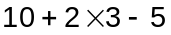 (1 mark)

(b) Expand 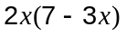. (1 mark)

(c) Factorise 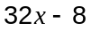. (1 mark)

(d) If 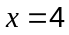 and 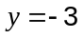 evaluate 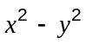. (1 mark)

(e) Write the number 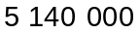 in scientific notation. (1 mark)

Question 2 (8 marks)
The two points A and B have coordinates A(6, 6) and B(3, 2).

(a) Determine the gradient of the straight line through A and B. (2 marks)

(b) Write down the equation of the straight line through A and B. (2 marks)

(c) A third point C has a -coordinate of 10 and lies on the line through A and B. What is the -coordinate of this point? (2 marks)

(d) Find the distance between the points A(6, 6) and D(14, 12). (2 marks)
Question 3 (8 marks)
A member of a local price watchdog group recorded the price of six similar sized jars of coffee on sale in a supermarket as follows:

 | $1.70 | $5.40 | $2.40 | $1.95 | $3.35 | $3.20

(a) What is the median price for these six jars of coffee? (2 marks)

(b) Calculate the mean price of a jar of coffee. (2 marks)

(c) What is the range of the prices? (1 mark)

(d) Why does it not make sense to calculate the mode of the six prices? (1 mark)

(e) If the most expensive jar of coffee was sold with a 25% discount, what would it actually cost? (2 marks)

Question 4 (7 marks)
Solve each of the following algebraically for the unknown.

(a) 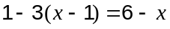 (2 marks)

(b) 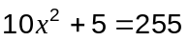 (3 marks)

(c) 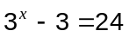 (2 marks)

Question 5 (6 marks)
(a) A sequence of numbers begins as follows.

98, 91, 84, 77, ...

(i) Explain how to find the next few terms of the sequence. (1 mark)

(ii) Write a recursive rule using algebraic notation to describe this sequence.
(2 marks)

(b) A radio station ran a competition in which the prize money of $480 was reduced by 50% every hour.

(i) The rule 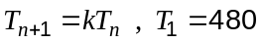 can be used to calculate the prize money during the th hour of the competition. What is the value of ? (1 mark)

(ii) The competition continued while the amount of prize money for the hour was more than $10. For how many hours did the competition run? (2 marks)

Question 6 (10 marks)
(a) Write down the equation of the line shown on the graph below. (2 marks)
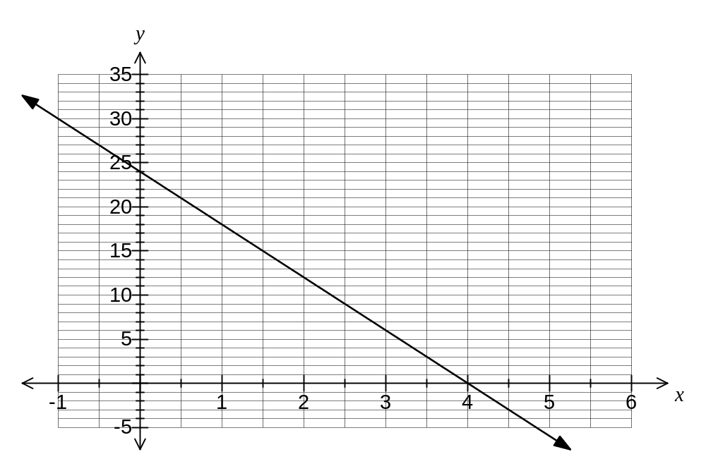

(b) Add the graph of 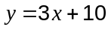 to the axes above. (2 marks)

(c)
(i) Complete the table below using the equation 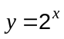. (2 marks)

 | 0 | 1 | 2 | 3 | 4 | 5

(ii) Add the graph of to the axes above. (2 marks)

(iii) Use your graph to solve 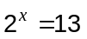 (2 marks)

Question 7 (6 marks)
Consider the first four rows of the number pattern below.

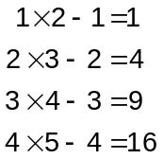

(a) In the space above, write down the next two rows of the number pattern. (2 marks)

(b) Write down the tenth row of the pattern. (1 mark)

(c) A conjecture stated that every number on the right hand side of this pattern will be a square number (a square number is an integer that is the square of an integer).

Use the examples above to test this conjecture and comment on whether or not they support the conjecture. (3 marks)

Additional working space

Question number: _________

Additional working space

Question number: _________

